Do all my Comments please

Introduction:
Feedback received as the following which I will need to resubmit: I have reviewed your revised Introduction chapter. You have done a good progress since last time. It is very encouraging that you have considered all my feedback comments and you have made all the changes/additions needed.
Nevertheless, research objectives should be limited to a number of two or three. Then, you can develop relevant research propositions (qualitative research methods) to the research objectives in the Literature Review chapter. Such research propositions enable the researcher to address the research objectives in a structured rationale.
Also, I would advise you to update some of the sources you have used with up-to-date ones (since 2010).
You have developed a sound Introduction chapter. Keep up the good work, Mohammed!
I remain at your disposal for any question.
Regards,

Number of words needed is (1200 words)

Literature Reviws:
- : Literature Review: The figure in your conceptual framework should be revised. Please check the guidelines which I provided you with past feedback - the relations among the displayed concepts should be clearly displayed and justified in a following discussion;

- Previous guidelines as mentioned for the above point:

Notes for the Literature Review
The key objective of the literature review is to demonstrate that your research will fill an important gap in the current research on this subject. As a general guideline, the literature review should:
- compare and contrast different authors' views on an issue;
- group authors who draw similar conclusions;
- criticise aspects of methodology;
- note areas in which authors are in disagreement;
- highlight exemplary studies;
- highlight gaps in research;
- show how your study relates to previous studies;
- show how your study relates to the literature in general;
- conclude by summarising what the literature says.

The purposes of the review are:
- to define and limit the problem you are working on;
- to place your study in an historical perspective;
- to avoid unnecessary duplication;
- to evaluate promising research methods;
- to relate your findings to previous knowledge and suggest further research.

The Research Problem
Defining are search problem allows for the formulation of a research question to be answered or a hypothesis to be tested. The statement of the problem provides the focus and direction of the study:
- Recall that a problem can be something to be explained, to be further understood or to be addressed;
- A good statement of the problem clearly defines the problem, states the concepts to be related in the study and identifies a feasible solution to the problem;
- By clearly stating the concepts to be related, a well-written problem statement helps to identify the variables to be investigated in the study.

Research Objectives
Research objectives outline the specific goals the study plans to achieve when completed. Research objectives should be explicit and clearly defined, and there is a high probability of meeting them. Good research objectives should be:
- Concrete statements describing what the research is trying to achieve;
- Achieved by undertaking the research;
- Grounded in the problem statement;
- Presented clearly and concisely;
- Logically/conceptually linked;
- Comprehensive of the different aspects of the research problem you identified;
- Clearly phrased in operational terms.

Research Questions and Hypotheses
(Hypotheses for Quantitative Research Methods - Propositions for Qualitative Research Methods)
A research question is a clear, focused and arguable question around which you plan to center your research. A research question can be answered directly through the analysis of data.
- Research questions are associated with the problem statement and can be answered directly through the analysis of data;
- Hypotheses are generated from specific theories, but research questions are often attempts to refute/validate various theories through the testing of their associated hypotheses.

Last but not least, it would be useful to create a conceptual framework to illustrate the correlations among the key concepts of your literature. Please check the following information about the kinds of variables and their role in developing a framework.

Main types of variables:
- Dependent variable;
- Independent variable;
- Moderating variable;
- Mediating variable.

Dependent variable (DV): Is of primary interest to the researcher. The goal of the research project is to understand, predict or explain the variability of this variable.
Independent variable (IV): Influences the DV in either positive or negative way. The variance in the DV is accounted for by the IV.
Moderating variable: Moderator is qualitative (e.g., gender, race, class) or quantitative (e.g., level of reward) variable that affects the direction and/or strength of relation between independent and dependent variable (Figure 1).
Mediating variable: surfaces between the time the independent variables start operating to influence the dependent variable and the time their impact is felt on it (Figure 2).

Moderating and Mediating Variable: Differences (Figure 3)
A moderator is a variable that affects the strength of the relation between the predictor and criterion variable. Moderators specify when a relation will hold. It can be qualitative (e.g., gender, nationality, etc.) or quantitative (e.g., level of reward). A mediating variable explains the relation between the predictor and the criterion. A mediator can be a potential mechanism by which an independent variable can produce changes on a dependent variable. When you remove the effect of the mediator, the relation between independent and dependent variables may go away.
Examples

Figure 1
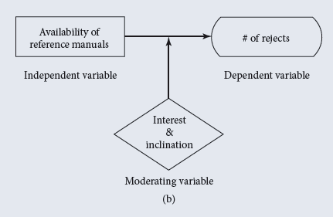
Figure 2

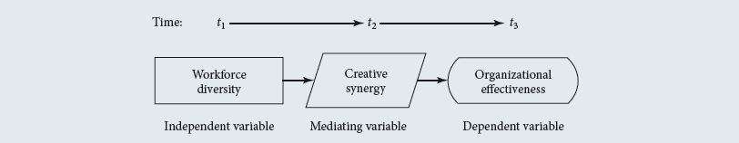
Figure 3

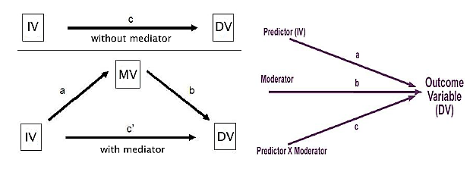

You have included several academic sources which discuss relevant concepts and theories to your research topic. However, there should be more effective critical analysis - research gaps have not been identified clearly. Also, research questions should be clearly derived from the critical analysis with relevant support and evidence.
Word count (3000words)

Methodology Notes:
  - Sampling methods: You have provided some information about the participants. However, you need to elaborate on how and why they were selected - selection rationale;
  - Data collection process and data analysis methods: Elaboration on the two sections is necessary. First, you need to discuss in more detail the stages of the data collection process and why there is such a structure in the process. Secondly, data analysis methods should also demonstrate evidence of compatibility of the chosen analysis tools with your research topic - explain what would be credited to your study by using these data analysis methods (practical approach).

Notes for the Research Design and Methodology
You have provided details for all the required areas that needed to be assessed. Nevertheless,
- Research methods need to be described further - advantages and disadvantages over others;
- Sampling methods: who the respondents are, how many they are, and how they were selected;
- Data analysis methods and data collection process should be developed in detail;
- Ethical considerations and/or limitations are missing.

Word count: 1800 words

Questions:
- As an industrial supplier company, what marketing-mix have you emplyed and how it helped in marketing your brand and products for the past four months till the moment?
How do you ensure that the respondents are aware of the marketing-mix models in order to reply to the question accurately? On the one hand, it would be useful to focus on particular elements (e.g. cost, communication, place, promotion, etc.) which derive from marketing-mix models. Then, you can analyse their answers and result to the marketing-mix models applied by the respondents. That requires to rephrase the question and isolate words and meanings from the respondents’ answers in your analysis afterwards. On the other hand, you should inform the respondents about the marketing-mix approaches before starting the interview and posing them the question as it is.
- Why do you change your marketing activities and based on what?
Initially, do they change their marketing activities? The question could be, “Do you usually change your marketing activities and what are the reasons to do or not do so?”.
- Do you think it is more profitable to be ahead of competitors and make a proactive marketing plans or reactive based on the market movements? Why?
“Do you think it is more profitable to be ahead of competitors and make a proactive marketing plans or reactive based on the market movements and why?”
- What are the marketing activities that the company have spent on in the last 4 months? Why?
It’s OK. You can just integrate the “Why” into the first part of the question, similarly to the previous one.
- How do you sit yourself as (a buyer/seller) in the position of power when negotiating with another party?
Excellent.
- What kind of customer-service that can give the edge to the seller to despite their price if high and competitor price? (By mean constant contact, personal train, personal relationship, long-history)
It does not make sense. Please rephrase.
- What innovative your company have initiated in the past four months and what was the reason of that innovation?
“Innovative” what?
- How does innovation give you the upper-hand price when compared to your competitors? If it does not allow you selling with a higher price, why buyers are not preferring your company?
This question should be preceded to the previous one. Also, “why buyers are not preferring your company?” – how do you result to it?
- Does customer’s knowledge about the product is beneficiary for your pricing and why? Does collaborators give you the advantage to achieve your innovation goals (such as selling at a higher price, not to be compared to another supplier)
The second part of the question is a close-ended question (Yes or No - quantitative research method). Additionally, how is it related to the first part of the question?
- How new entrants to you market compete with your company? What strategy do/did your company employed?
Excellent.
- What is your company’s market strategic approach?
Probably this question should be absorbed by the first question of the interview question. Otherwise, you may omit the first question and keep the current one. Finally, if the respondent’s marketing-mix approach is different than his/her company, then it should be clearly given.
- Which of the following is describing your company’s approach: customer-oriented, competitor-oriented, inter-functional, long-term focus or profit focus?
The same as above.
- Have your company employed/considered rebranding? Why?
You need to make the respondent to focus on the reasons for each case.
- What does encourage your management to review their infrastructure, capability, internal and external environment? And why?
You need to make the respondent to focus on the reasons for each case.
- Are your customer’s price-sensitive? Whether yes or no, what are the pricing based that you are employing and why?
Good.
- Will your company invest in their infrastructure to enhance innovation for higher profits? And why?
Good.
According to the research objectives which you have identified in the introduction, it should be noted that the first research objective is not addressed in the interview questions. Moreover, I advise you to adjust the sequence of the interview questions coherently so as to group them and smoothly transit from the one concept to another. Last but not least, the second research objective in the introduction chapter refers to a company’s crisis. Sampling methods should clearly discuss that the participants/respondents refer to saturated companies and the participants/respondents must be saturated companies evidently. Otherwise, the second research objective should be revised and rephrased and the saturation status of the Saudi Arabian market should be spherically described and synthesized in the literature review.
Please make the appropriate amendments asap and let me have a final look at the questions before you proceed to the data collection process.

